

**Final Year Project**

**(Development of an Application to Improve Mental Health )**

**Interim Report**

**School of Electrical and Electronic Engineering**

**Academic Year 2022/2023**

**Semester 1**

**Name: Shoon Zhen Yong**

**Matric Number: U1920283L**

**Contents**

1. **Introduction** 
   1. **Background Introduction --------------------------------------------------------------- 3**
   2. **Project Plan/Strategy------------------------------------------------------------------- 4-5**
2. **Work Conducted**
   1. **Team Work ---------------------------------------------------------------------------------6**
   2. **Individual Work------------------------------------------------------------------------7-10**
3. **Future Work -----------------------------------------------------------------------------------10**
4. **Conclusion -------------------------------------------------------------------------------------10**
5. **References --------------------------------------------------------------------------------------10**

**1.Introduction**

**1.1 Background Introduction**

Mental illness refers to a wide range of mental health conditions which will affect your mood, in the way you think and act. [1] According to World Health Organization, one in seven 10 to 19-year-olds suffers under mental disorder, while approximately 15% of adults aged 60 and over suffer from mental disorders. Untreated mental health problem will negatively impact our life quality which includes our health, education and even career. Although there are many activities spreading awareness about the importance of having good mental health to the public, but still there’s many people who are suffering from mental health [2] would not like to seek help due to public stigma and fear of admitting they are suffering from mental health issues.

Hence, our team have decided to create a mental health application to aid people who have mental health issues. There will be two user perspective in our application: Psychological First Aider and Target User.

For Target User, mobile application will be developed with three main features which is consultation, activity tracker and rewards. In consultation features, target users’ identity will be kept as anonymous. When they initiate the consultation sessions with Psychological First Aider, they can share their personal feelings with them. Our application will then provide the target user a mood analysis report for them to have a better understanding on their emotions throughout the consultation session. Besides consultation, target users can carry out several activities such as meditation, drawing, text and video diary as all these activities are useful to relax their mood and mind. Lastly, completed activities can be converted into points and can be used to redeem rewards from our rewards page. Rewards redeemed through the points system can be sent to anyone through our application to show care and support.

As for First Aider, both web and mobile application will be built. Psychological First Aid course will be provided to the First Aider to equip them with the right skills and knowledge to help out. First Aider will learn the course through series of videos and will be accessed through our machine learning feature through their tone, vocabulary usage and body language during quizzes. To be qualified as a recognized First Aider, they will need to pass all the courses and obtain an in-app badge from our application. Once they are recognized, they will then be able to accept the consultation sessions requested by the users.

All in all, this project aims to provide low-cost solutions to improve mental illness among people through community support. We hope that it will raise public awareness towards mental health issues and would enable more volunteers to participate by becoming one of the Psychological First Aider.

As this project will be completed in a team of 4, we have already distributed the work among ourselves. For me, I will be working on the activities tracker which more details will be discussed in the following sections. Our application will be mainly using Flutter to develop the mobile and web application; and [3] Azure Cognitive Service for all the machine learning related features.

**1.2 Project Plan/Strategy**

**Semester 1 AY22/23**

|  |  |
| --- | --- |
| **Schedule** | **Task** |
| Week 1 | Analyze all the past Microsoft Azure projects |
| Week 2 | Analyze all the Microsoft Azure Tools available |
| Week 3 | Analyze all the problems experienced by worldwide |
| Week 4 | Brainstorms idea  Review on existing solution |
| Week 5 | Meet up with relevant parties to understand more about project topics |
| Week 6 | Decide on an idea and start designing the structure of the application  Credit Planning on Microsoft Azure Technology  Submit Project/Strategy to Supervisor -12 Sept 2022 |
| Week 7 | Construct the user workflow/database systems through Lucid Chart |
| Week 8 | Wireframe the prototype of the application through Figma and decide the tech stack of the application. |
| Week 9 | Design the database ( ER diagram )  Setting up the version control at Github and coding environment  Set up the cloud database in Azure  Start Coding according to work division |
| Week 10 | Make Preparation for Imagine Cup (Epic Challenge)  Submit Proposal and a 3-minute video |
| Week 11 | Continuous Integration and Continuous Deployment (CI/CD) |
| Week 12 | Do Interim Report  Continuous Integration and Continuous Deployment (CI/CD) |
| Week 13 | Do Interim Report  Continuous Integration and Continuous Deployment (CI/CD)  Submit Interim Report to Supervisor -7 Nov 2022 |

*Table 1. Project Planning for Semester 1 AY22/23*

**Semester 2 AY22/23**

|  |  |
| --- | --- |
| **Schedule** | **Task** |
| Week 1 | Analyze all the available tools on Google Cloud platform available |
| Week 2 | Set up the Google cloud database  Start migrating from Microsoft Azure to Google Cloud |
| Week 3 | Continuous Integration and Continuous Deployment (CI/CD) |
| Week 4 | Continuous Integration and Continuous Deployment (CI/CD)  Preparation for Imagine Cup Semi-finals |
| Week 5 | Continuous Integration and Continuous Deployment (CI/CD) |
| Week 6 | Continuous Integration and Continuous Deployment (CI/CD) |
| Week 7 | Testing the application and prepare to submit for Google Solution Challenge (early of March) |
| Week 8 | Prepare for draft final report |
| Week 9 | Prepare for draft final report |
| Week 10 | Submit Interim Report to Supervisor -24 Mar 2023 |
| Week 11 | Complete final report  URECA poster submission - 31 March 2023 |
| Week 12 | Submit final report to supervisor and examiner - 6 Apr 2023 |
| Week 13 | Prepare for oral presentation and arrange the project demonstration schedule with examiner |
| 08-10 May 2023 | Oral Presentation |
| 15 May 2023 | Submit Final Report to Main Supervisor |
| 31 May 2023 | Submit Abstract of URECA research project to supervisor.  Submit URECA Project Consumable Claims via Student Intranet. |
| 15 Jun 2023 | Submit Research paper to supervising professor  Submit Reflection of research experience to supervisor |

*Table 2: Project Planning for Semester 2 AY22/23*

**2.** **Work Conducted**

**2.1 Team Work**

**Ideation**

Originally, we do not have a fixed title for our Final Year Project (FYP), hence we first started off with the ideation period. According to the rules of the Microsoft Imagine Cup, we will need to develop an application in one of the four categories, which is Earth, Education, Health and Lifestyle. In order to understand more about the competition and what have others have been doing for the past, we spent time looking through all of the projects done by the past winners in Microsoft Imagine Cup.

After looking through all of their projects, we have come to a conclusion that the judges are more interested in the Health category as most of the Finalists are from that particular category. However, we do not limit ourselves in the Health category. Hence, we started to think of various ideas such as virtual wardrobe for visual impairments, fake news detection application, digital health platform and a recycling application.

However, most of these ideas have been readily available in the market and it does not show uniqueness and scalability of our possible product. Hence, we took another 1-2 weeks time to research on other possible applications that can be developed. In the end, we have narrowed down to 2 ideas which is the mental health application and blood donate application.

For the mental health application, the original features include chatbot, video diary. Community page, and video consultation with psychologist. In order to have a clearer vision of mental health, we decided to approach relevant organization such as University Wellbeing Office (UWO) from NTU to obtain feedbacks on our proposed solution. In the meeting with the Director of UWO, he mentioned that our solution was too similar with existing application on the markets and suggested a few more features that we can try to develop to create uniqueness of our product.

For the blood donation application, we planned to develop an application that can improve resource management of blood supply with 3 user perspective – users, hospital and blood bank. Users can make appointment for blood donation and receive latest information regarding blood stock. Besides, users will be notified if blood stock of specific blood types runs low and he is eligible for blood donation or not. Users will be able to conduct haemoglobin level test to check for their eligibility through machine learning on the eyes. On the other hand, our application would forecast the blood demand on each day by using machine learning with the possible blood usage based on the operation schedule and past accident data. Blood bank will be able to update the latest supply data and receive blood request from hospital.

Initially, we did not receive any replies from Red Cross Singapore and we also tried calling blood bank at Westgate. However, they were not able to schedule a meeting with us without approval from the headquarter. After several try-outs, we decided to finalize our idea towards developing a mental health application.

**2.2 Individual Work**

**User Flow**

After rounds of discussions, we had finalized the different activities features that we would like to implement in our application. We then continued with the user flow design by using Lucid Chart. User workflow is important as it will help us to have a better understanding on how our user navigate through the pages and implementing the features that is being required. For my part, I’m in charge of the activities tracker features.

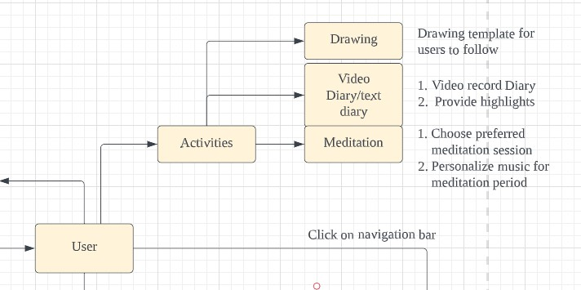

*Figure 1: Activities Tracker*

As shown in Figure 1, when user login to our page, users can enter the Activities Tracker main page by clicking on the navigation bar below in the application. From the activities tracker, there will be 4 different activities that can be chosen by the user which is drawing, video diary, text diary and meditation.

In the drawing activities, user will be provided a template for them to draw and colour. For video diary, user can upload or record video through our application and our application for provide a weekly highlights to review what they have experienced in the past week. For meditation feature, users can choose the type and duration of their meditation session and able to personalize their preferred music in our application.

After constructing the user workflow, we then continued with our wireframing by using Balsamic for low fidelity and Figma for high fidelity design.

**Wireframe - Low Fidelity**

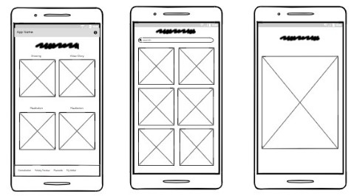

*Figure 2: Activities Tracker Low Fidelity*

Figure 2 shows the page title on top of the pages and the navigation bar will be placed at the bottom of our page. The most left diagram shows the 4 activities that can be chosen by the user. The middle diagram shows the types of drawing or type of meditation session that can be chosen by the user. The most right diagram shows the page after selecting the drawing/meditation session.

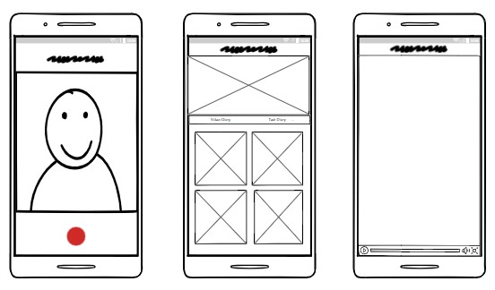

*Figure 3: Activities Tracker Low Fidelity*

Figure 3 shows the video diary function. User can record their daily feeling or upload video to our application. Our application will perform several video editing using machine learning algorithm and provide highlights for all the videos being recorded or uploaded weekly.

**Wireframing - High Fidelity**

After completing the low fidelity design, we then move on to high fidelity wireframe by using the Figma. We have finalized our color hex code to #FE8235 and font using Epilogue.

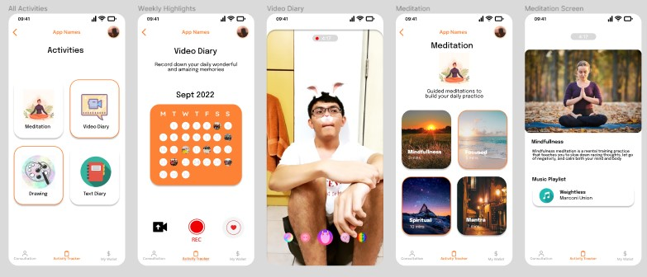

*Figure 4: Activities Tracker High Fidelity*

Figure 4 shows the first two activities of our application which is the video diary and meditation. User can either choose to record or upload videos in our application. Tiny little dots will show which date does the user have recorded or uploaded a personal video in our application. Filters will also be provided for the user when they do a video recording to increase the interaction of users with the application.

For meditation, user can choose the type of meditation and personalize their own music for the meditation session.

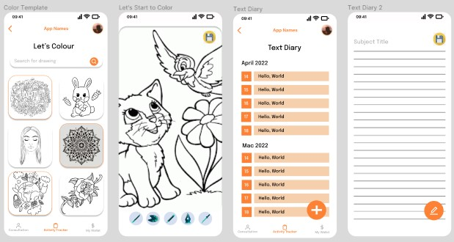

*Figure 5: Activities Tracker High Fidelity*

Figure 5 shows another two activities of our application which is the drawing and text diary. User will be able to choose the drawing template that they want and colour it with the colour tool provided. For text diary, user can choose the background template and type out what they feel about that day. All the texts will be stored in the user account for them to look back on what they feel or experience on that day.

**3. Future Work**

Our team will be focusing on the submission proposal for the Epic Challenge of Microsoft Imagine Cup which will end on 30th November 2022. The submission criteria includes a project proposal of our mobile application and a 3-minute video presentation of our project. We will complete both project proposal and video presentation a week before the deadline for our supervisor to check through.

After the proposal submission, we will start to develop our application as the submission for Microsoft Imagine Cup Round 1 will be ending on 27th January 2023. We will split the job according to what we have done so far and integrate it together. We will use Flutter to develop our mobile application and Microsoft Azure Cognitive Services to develop our services.

After the submission of Microsoft Imagine Cup, we will be also submitting our proposal to Google Solution Challenge by changing our cloud services to Google Cloud Services.

**4. Conclusion**

In conclusion, our team has completed the ideation and wireframing. We are now currently into the developing phase where we will code out our web and mobile application in the next few week’s time. As the time span is quite limited for the Microsoft Imagine Cup, we hope that we can fully develop the mobile application in the next 2 months time before the submission of Microsoft Imagine Cup Round 1 which will be ending on 27th January 2022.

**5. References**

[1] World Health Organization, “Adolescent mental health”, 17 November 2021. [Online]. Available: [https://www.who.int/news-room/fact-sheets/detail/adolescent-mental-health](https://www.who.int/news-room/fact-sheets/detail/adolescent-mental-health%20)

[2] Emily Simonian, “Why do people avoid mental health treatment?” [Online]. Available: <https://thriveworks.com/blog/why-people-avoid-mental-health-treatment/>

[3]Azure. (2022) *Azure Cognitive Services* [Online] Available: <https://azure.microsoft.com/en-us/products/cognitive-services/>